**Welcome to “SQLRDD Extreme Edition” Beta program**

SQLRDD Extreme Edition (SQLEX) is the result of an extensive investment in development, where we put together all the experience acquired in more than 14 years dealing with DBF/SQL dilemma and addressing the needs of hundreds of users worldwide.

SQLEX is not a common SQLRDD rewrite. We’re introducing a completely new approach to access a result set based architecture (SQL) from a xBase DML, and it is 100% coded in C language.

Since we first released SQLRDD, the main concern of our users is PERFORMANCE. And that’s exactly what’s we’re improving in this new product. We experienced a performance improvement in SKIP, SEEK, APPEND, etc., from 5 to 15 times (depending on database system)! But of course your app will not get 10 times faster just by replacing RDD, because it is not coded only by DML commands. You also use many other commands and functions that are not related with RDD or data access. **In fact, I hope to hear from you the real gain in your application**.

**1 – Installing SQLEX:**

You may simply replace sql.lib in your xHB\lib folder by the one included in zip file. Do no forget to BACKUP your current sql.lib.

You will also find a new set of samples that should be unzipped to xHB\samples\sqlrdd folder.

Note: This version of SQLEX requires **xHarbour Builder April 2009**.

**2 – Changes in your code:**

You should add to the top of your main PRG:

REQUEST SQLEX

All operations should be done with SQLEX name instead of SQLRDD, so you may need to review all table opening and creating routines.

**IMPORTANT:** SQLEX connects to database only through ODBC, so you should setup an ODBC DSN in order to use it. Connection routines are exactly the same from SQLRDD.

**4 – Currently supported databases:**

SQLEX at this stage supports only ODBC connections to following databases (please observe database version):

* MSSQL Server 2000 or 2005
* Postgres 8.2 or 8.3
* Firebird 2.1
* MySQL 5.1
* Oracle 9i and 10g

**Important note about MySQL:** The ODBC driver version 5.1.5 from MySQL.org is completely broken and may cause unexpected results. You should use ODBC driver version 3.51 that can be downloaded from following link:

http://dev.mysql.com/downloads/connector/odbc/3.51.html#win32

**Important note about Postgres:** When creating the ODBC DSN, Postgres driver automatically sets the option “Boolean as Char”. You should uncheck this option in ODBC setup like in image below. If you create the DSN from source code using SR_InstallDSN() function, you can fix this option by adding “BoolsAsChar=0;” in parameter list.

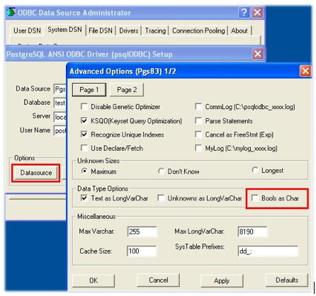

**5 – How to report bugs:**

Please send me a direct email to [marcelo@xharbour.com](mailto:marcelo@xharbour.com), with complete error description, error log file, and a reduced, self-contained sample that shows the error, if possible. A good idea is to try to simulate what your application does inside one of SQLRDD samples included in zip file. We would be glad to hear from you not only bugs but also the improvements you experienced in your application processing time.

**6 – Known issues:**

* SR_ChangeStruct() is still broken in SQLEX and calls should be kept under SQLRDD;
* IndKeyNo() will always return a number in 1-250 range. This is a workaround since SQL has no similar concept, and to get the correct information from COUNT(*) queries may decrease performance dramatically;
* Multilang features still not tested;

SQLEX will be a free upgrade to all Enterprise and SQLRDD users with active Update & Service Subscription at xharbour.com. **This Beta Program is also restricted to active subscribers, and all files and information supplied should be considered confidential and not redistributable in any way**.

Have fun,

Marcelo Lombardo  
www.xharbour.com